Aboriginal People and Australian Football in the Nineteenth Century: They Did Not Come from Nowhere.

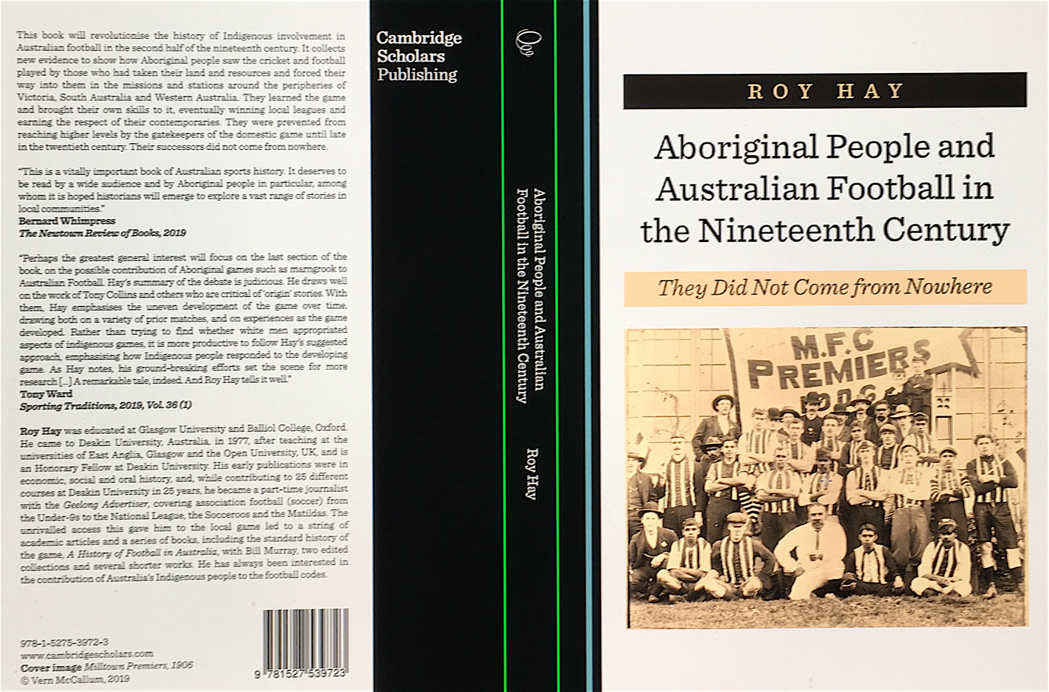

Paperback edition is now available. Special launch price from SESA via
roy@sesasport.com.au
$39.95

CSP website link
https://www.cambridgescholars.com/aboriginal-people-and-australian-football-in-the-nineteenth-century
If you open this link and then hit the View Extract tab you will have the first 30 pages of the book from which you will get a good sense of what it is about and can order it directly from the publisher if you wish. Australian bookshops can order it for you or I can supply direct from Bannockburn if you contact me at roy@sesasport.com.au

Reviews and articles
Gideon Haigh, ‘Field reports yield seeds’, Weekend Australian, 20-1 April 2019, p. . https://www.theaustralian.com.au/arts/books/field-reports-yield-seeds/news-story/fa904f4d5a5b46055516de882e376129
Bernard Whimpress, Newtown Review of Books, 23 May 2019,
https://newtownreviewofbooks.com.au/roy-hay-aboriginal-people-and-australian-football-in-the-nineteenth-century-they-did-not-come-from-nowhere-reviewed-by-bernard-whimpress/
Colin Ritchie, Almanac Book Review, 24 July 2019, https://www.footyalmanac.com.au/almanac-book-review-aboriginal-people-and-australian-football-in-the-nineteenth-century-they-did-not-come-from-nowhere-by-roy-hay/#comment-1107891
Cam Ward, ‘Footbrawl over state of origin story: Academic rejects footy’s indigenous start’, Geelong Advertiser, 7 June 2019, pp. 28–9. http://regionalnews.smedia.com.au/geelongadvertiser/Afterlogin.ashx?Origin=/geelongadvertiser/default.aspx?publication=NCGA&Id=1&d=2019-10-31&r=none&c=E8D37B06891518A5CE95811682E8C357
Steven Carroll in the Non-Fiction Review page of Spectrum in the Age, 1 June 2019, p. 22.
Chalpat Sonti, ‘Book looks back on local sporting legends’, Portland Observer, 31 May 2019, p. 10.
Tony Ward, Sporting Traditions, vol. 36 no. 1, pp. 77–9.
Trevor Ruddell, The Yorker, Issue 68, Autumn 2019, pp. 30–1.
‘Local Indigenous cricketers and footballers featured in book’, Hamilton Spectator, 25 July 2019, p. 5. www.spec.com.au
Robert Pascoe, ‘Aboriginal People and Australian Football in the Nineteenth Century: They Did Not Come from Nowhere’, The International Journal of the History of Sport, DOI: 10.1080/09523367.2019.1675036. Published online 16 October 2019, https://doi.org/10.1080/09523367.2019.1675036

Podcasts
Roy Hay with Tony Collins, Rugby Reloaded. 62 Race, racism and the origins of Aussie Rules
https://soundcloud.com/user-523674328/62-race-racism-and-the-origins-of-aussie-rules/s-brosH
Roy Hay with Keith Rathbone, New Books in Sport, 29 July 2019, https://newbooksnetwork.com/roy-hay-aboriginal-people-and-australian-football-in-the-19th-century-cambridge-scholars-2019/

State Library of Victoria
http://search.slv.vic.gov.au/primo-explore/fulldisplay?docid=SLV_VOYAGER3807129&context=L&vid=MAIN&lang=en_US&search_scope=Everything&adaptor=Local%20Search%20Engine&tab=default_tab&query=any,contains,Aboriginal%20People%20and%20Australian%20Football%20in%20the%20Nineteenth%20Century

